2012-2022

Sudden Unexpected Infant Death (SUID) Report

  - Fulton & DeKalb Counties



This report was authored by:

Bridget Hamilton PhD, MPH, RN
Trina Salm Ward PhD, MSW
Donye Caldwell MPH, CPST
Unnati Bhatt MPH
Alayna White
Terri Miller MPH, CHES

  - Funding Statement

This report was made possible through funds provided by the Centers for Disease Control’s Sudden Unexpected Infant Death Case Registry Program

  - Acknowledgements

Our team would like to acknowledge the work by the state and local level Child Fatality Review Committees in their tireless efforts to safeguard Georgia’s children. It is through your hard work that we are able to understand more about contributing factors and work towards a solution.

  - Executive Summary

- In 2022, approximately 4 infants died per week due to sleep-related causes across the state of Georgia.
- A majority of these deaths were preventable

  - National Statistics

Across the United States, approximately 3,500 infants die from sudden unexpected infant deaths (SUID). Between 1990-1998 SUID rates declined by 45%, after implementation of the American Academy of Pediatrics (AAP) recommendation that infants be placed on their backs to sleep through the Back to Sleep/Safe to Sleep campaign led by the NIH. Since this time, the SUID rate has declined less than 10% and the prevalence of back to sleep position has plateaued. There are three common types of SUID: 1) Sudden Infant Death Syndrome (SIDS), 2) Unknown causes, and 3) Accidental suffocation and strangulation in bed. In 2020, SIDS accounted for 1,389 deaths (41%), unknown cause accounted for 1,062 deaths (32%), and accidental suffocation and strangulation in bed accounted for 905 deaths (27%). In Georgia (GA), The 2020 SUID rate was 127.9 per 100,000 live births, higher than the U.S. rate of 92.9 (CDC, 2020). The Georgia Department of Public Health (DPH) is the lead agency charged with preventing injury, disability, and disease, promoting health and well-being, and preparing for and responding to disasters. The Injury Prevention Program (IPP), located in DPH’s Division of Health Protection, has a long-standing history of collaboration across agencies and sectors, to address preventable harm to its citizens across geography, gender, race, ethnicity, and socioeconomic status. GA is composed of 159 counties served by 18 public health districts supported through the state health department. In all counties and districts, injury-related morbidity and mortality is a major public health burden across the lifespan. Among the leading causes of injury-related mortality, SUID contributes to approximately 3 infant deaths per week in the state.

  - Georgia Child Fatality Review (CFR)

Georgia's Child Fatality Review Panel (CFRP), a statutory body mandated by the Georgia State Legislature in 1990, is composed of an appointed body of representatives who oversee the process of reviewing child fatalities. Charged with examining the circumstances around child deaths, its mission includes providing high-quality data, training, technical assistance, investigative support services and resources to prevent and reduce child abuse and fatalities.
In 2007, the Georgia Child Fatality Review Panel (CFRP) was designated to serve as the third of Georgia's three CAPTA Panels,2 and in 2011, CFRP bylaws were amended to include its role as a CAPTA citizen review panel in the description of its purpose as a statutory body. In 2014, the administrative responsibility for child fatality review transferred from the Office of the Child Advocate (OCA) to the Georgia Bureau of Investigation (GBI). The CFRP is supported by staff who review and monitor the work of Georgia's 159 county Local Child Fatality Review (LCFR) committees, analyze results, and develop recommendations based on their findings and issues raised by local committees and CFRP members.

LCFR Committees are made up of community stakeholders such as law enforcement, educators, health care providers, public health, and community members. LCFR members discuss prevention measures and ways to mobilize the community for the protection of children within the given jurisdiction. Not all cases are reviewed, but the goal of the committee is to review enough cases to represent deaths within the county. Data is collected during these meetings and entered into a national database managed by The National Center for Fatality Review and Prevention (NCFRP). The data from included in this report is data entered by the LCFRs of Fulton and DeKalb Counties.

  - Definitions

- Sudden Infant Death Syndrome (SIDS) – cause assigned when there is the death of an otherwise healthy infant (less than 1 year old) that cannot be explained after a thorough case investigation, including death scene investigation, autopsy, and review of the clinical history.
- Sudden Unexpected Infant Death (SUID) – a sudden and unexpected death, whether explained or unexplained (including SIDS) occurring during infancy.
- Sleep-Related Death – a sudden, unexpected infant death that occurs during an observed or unobserved sleep period, or in a sleep environment.

  - Overview of the Dataset

A total of 1,685 sleep-related death cases have been reviewed by LCFR between 2012 and 2022. A total of 153 sleep-related death cases were reviewed in Fulton County and a total of 119 sleep-related death cases were reviewed in DeKalb County. The data included in this report was collected from the 272 sleep-related deaths identified by the LCFRs in Fulton and DeKalb Counties between 2012-2022.

  - The Study Areas – Fulton and DeKalb Counties

DeKalb County

DeKalb County is the fourth most populated county in the metropolitan Atlanta area. Cities within DeKalb County include Atlanta, Avondale Estates, Brookhaven, Chamblee, Clarkston, Decatur, Doraville, Dunwoody, Lithonia, Pine Lake, Stonecrest, Stone Mountain, and Tucker.

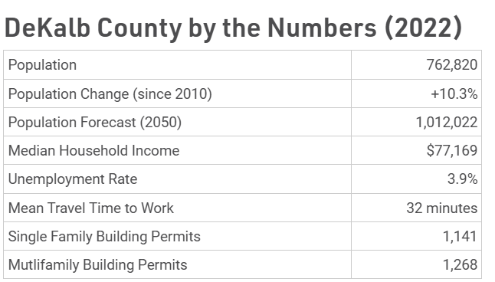
*Data is from the Atlanta Regional Commission

Fulton County

Fulton County is the most populus county in the state of Georgia. Within Fulton County are the cities of Atlanta, Alpharetta, Chattahoochee Hills, College Park, East Point, Fairburn, Hapeville, Johns Creek, Milton, Mountain Park, Palmetto, Roswell, Sandy Springs, Union City, and South Fulton.

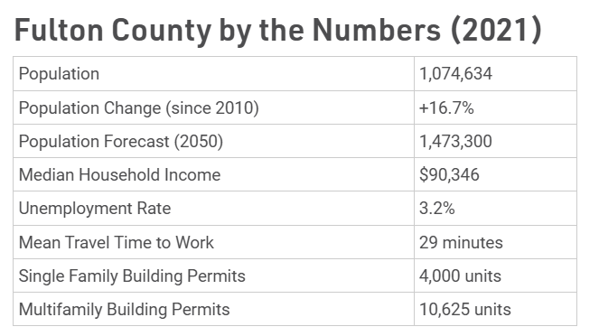
*Data is from the Atlanta Regional Commission

  - The Geography of CFR Reviewed Sudden Unexpected Infant Death (SUID)

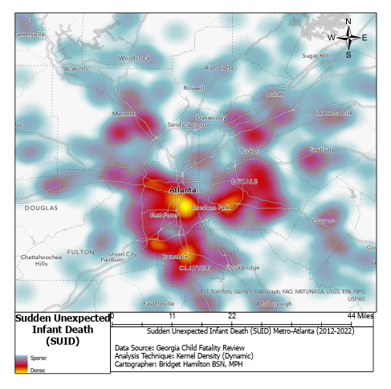

The hot spot map above shows the number of cases reviewed by LCFR in the metro-Atlanta area. Areas that are highlighted in red have the greatest number of cases, yellow slightly less, and blue have the least amount. The greatest number of cases in Fulton County are found in the East Point area. In DeKalb County, the greatest number of cases are found in the Gresham Park area.

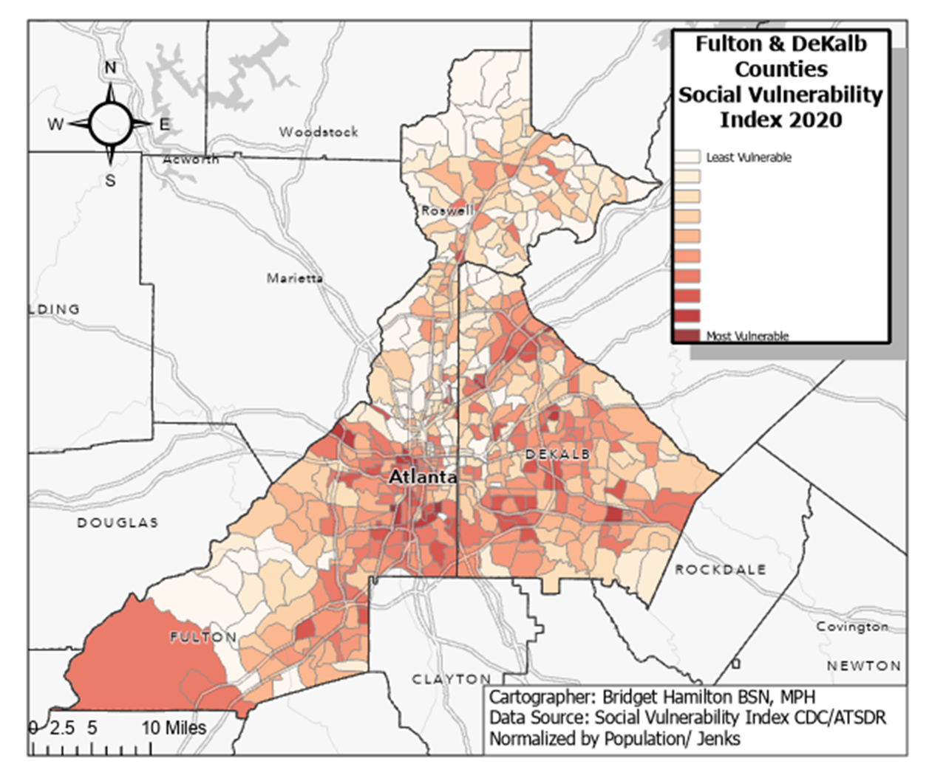
Social Vulnerability refers to the demographic and socioeconomic factors (such as poverty, lack of access to transportation, and crowded housing) that adversely affect communities that encounter hazards and other community-level stressors. These stressors can include natural or human-caused disasters (such as tornadoes or chemical spills) or disease outbreaks (such as COVID-19).
The Centers for Disease Control and Prevention and Agency for Toxic Substances and Disease Registry Social Vulnerability Index (hereafter, CDC/ATSDR SVI or SVI) is a place-based index, database, and mapping application designed to identify and quantify communities experiencing social vulnerability. In neighborhoods throughout Fulton and DeKalb Counties, SUID is happening in some of the most socially vulnerable communities in the metro area.

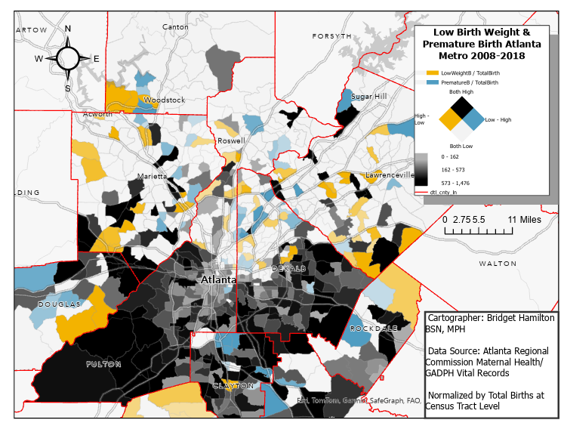
Infants born premature are vulnerable to many complications. SUID has been identified as a key complication of both premature birth and low birth weight. Infants born in families facing multiple social determinants of health are at greater risk for SUID since they are at greater risk of having premature and low birth weight infants. These outcomes similarly align with the occurrence of SUID in communities throughout Fulton and DeKalb Counties.

  - Child Fatality Review (CFR) Dataset Demographics

Demographic | No. (%) – DeKalb Child Fatality Review 2012-2022 | No.(%) – Fulton Child Fatality Review 2012-2022 | No. (%) - Georgia Child Fatality Review 2012-2022 | No. (%) - National Child Fatality Review 2004-2019
Total Number of Cases Reviewed | 119 | 153 | 1,682 | 28,110
Race/Ethnicity
Black | 104 (87.4%) | 133 (87%) | 952 (56.6%) | 9,839 (35%)
White | 6 (5.1%) | 12 (7.9%) | 547 (32.5%) | 15,461 (55%)
Hispanic | 5 (4.2%) | 4 (2.6%) | 101 (6%) | 4,498 (16%)
Multiracial | 4 (3.4%) | 2 (1.3%) | 66 (3.9%) | 1,124 (4%)
Asian | 0 (0%) | 2 (1.3%) | 12 (0.7%) | 281 (1%)
American Indian/Alaska Native | 0 (0%) | 0 (0%) | 0 (0%) | 843 (3%)
Unknown | 0% | 0% | 4 (0.2%)
Gender/Sex
Female | 55 (46.2%) | 73 (47.7%) | 758 (45.1%) | 11,806 (42%)
Male | 64 (53.7) | 80 (52.3%) | 924 (54.9%) | 16,304 (58%)
Year
2012 | 13 (11%) | 14 (9.1%) | 147 (8.7%)
2013 | 8 (7%) | 17 (11.1%) | 142 (8.4%)
2014 | 15 (12.6%) | 21 (13.7%) | 159 (9.5%)
2015 | 11 (9.2%) | 22 (14.4%) | 174 (10.3%)
2016 | 8 (6.7%) | 24 (15.7%) | 154 (9.2%)
2017 | 15 (12.6%) | 6 (3.9%) | 149 (8.9%)
2018 | 12 (10.1%) | 10 (6.5%) | 165 (9.8%)
2019 | 10 (8.4%) | 15 (9.8%) | 150 (8.9%)
2020 | 12 (10.1) | 10 (6.5%) | 143 (8.5%)
2021 | 8 (6.7%) | 9 (5.9%) | 146 (8.7%)
2022 | 7 (5.9%) | 5 (3.2%) | 153 (9%)

Across jurisdictions, the peak of SUID occurs around 2 months and begins to drop off around 3 months. In national CFR data, 79% of cases are between 0-4 months. It is agreed upon by researchers that age is linked to factors related to the infant’s developmental stage and arousal responses to hypoxia. Additionally, younger infants have less developed motor skills, so they lack the ability to move away from an asphyxia threat in a non-safe sleep environment context (i.e. bedsharing, soft objects in the sleep space, ect.). Other risk factors such as maternal smoking and low birth weight may also be linked to age.

It is essential that families are provided with safe sleep education at every opportunity pre-birth, following birth, and in subsequent encounters throughout the first year of life. Between 0-4 months is a critical time to provide this education. Additionally, it is essential that families are asked about adequate support prior to hospital discharge and during these early months of life. Asking the question, “Do you have all of the help you need?” could open the door to connect families with key essential services to support them during this first year.

Income Related Factors & Economics



  - Employment

Child Fatality Review 2012-2022
Child Fatality Review 2012-2022

Across jurisdictions, over half of caregivers were employed. This dataset does not provide details on type of employment (i.e. full time, part time, temporary, ect.) but it is well established within the SUID research that SUID has a close relationship with economics. Employers could play a key role in SUID, and the workplace could be an ideal setting to for SUID interventions. Free crib and bassinet programs could have a profound impact on SUID rates within communities. Additionally, job fairs and career development settings could be beneficial for capturing the other half of the population who is unemployed or underemployed. When caring for families, it is key that providers and community workers ask about employment and connect families with resources. Childcare is an essential need for families where all caregivers are working. Programs such as the Childcare and Parent Services Program (CAPS) are helpful in alleviating the financial burden associated with childcare.

  - Social Services

Child Fatality Review 2012-2022

Child Fatality Review 2012-2022

Over half of the families across both counties were enrolled in Medicaid at the time of the child’s death. In Georgia, basic eligibility for Medicaid includes criteria such as being pregnant or being a child or teenager. Additionally, there are financial limits in order to qualify for all of these programs, with TANF being the lowest. The resource limit to qualify for TANF is a gross income of less than $784 a month for a family of three and countable assets of less than $1,000. Receipt of cash assistance is limited to 48 months in a lifetime, however that limit can be extended if there is justification for it (i.e. domestic violence, physical or mental incapacity). There is also a requirement to cooperate with Child Support Services. As of 2023, there were only 4,521 families across the state of Georgia enrolled in TANF. While these numbers are not a rate of the overall population, it is notable that there is a percentage of almost 6% of these cases in DeKalb County and 3% of these cases in Fulton County in the CFR dataset. SUID is well established to have linkages to poverty. This data indicates that this may be the case in Fulton and DeKalb Counties and that interventions to address poverty may be beneficial in addressing SUID. In addition, there are families interfacing with multiple government assistance programs. So, to address SUID, it may be beneficial to place interventions in the settings of these programs to enhance the support being offered to these families.

  - Housing Related Factors

Child Fatality Review 2012-2022

Child Fatality Review 2012-2022

Across both counties, SUID cases occurred among families who endorsed moving (9.1%-16%) and overcrowded residences (15.8%). In DeKalb County, the median household income in 2023 was $77,683. In Fulton County, the median household income in 2023 was $91,490. It is well established in the SUID literature that poverty factors such as housing and income play a role in the occurrence of SUID in populations. Dense housing, in particular, has been found to have a relationship with the occurrence of SUID, potentially due to the exposure of second-hand smoke. Smoking cessation interventions could be impactful in curbing SUID rates at the population level. In addition, interventions placed in communities with high density housing may be beneficial for the prevention of SUID.

  - Caregiver Education

Child Fatality Review 2012-2022
Child Fatality Review 2012-2022

Across both counties, the majority of caregivers had at least a high school education. A smaller number had post-graduate education, but this number was larger in DeKalb County. There are four school districts across Fulton and DeKalb Counties with graduation rates around the state average of 88.4%. This data indicates that high school may be an opportune time to educate individuals about safe sleep. Additionally, there are numerous colleges and universities across both counties. It is possible that these settings may be good placements for interventions. Education and health are closely linked. Therefore, it is key to integrate safe sleep education into broader health education whenever possible.

Additionally, hospital based prenatal classes have been shown to be effective for educating parents about safe sleep. Low cost or free prenatal classes would be a benefit to families living in both counties, not just to address sleep, but also to address all aspects of infant health, especially for parents who may not have had access to education about infant sleep and/or infant health in high school and/or college.

The Sleep Environment



  - Incident Sleep Place

Child Fatality Review 2012-2022

Across both counties, most deaths occurred in the adult bed. This percentage was higher in Fulton County. The crib was the place of death for 14.3% of sleep-related cases in Dekalb County but only 6.5% of the cases in Fulton County. It is possible that access to cribs is easier within Fulton County, or it could be driven by unknown factors. Expanding crib access in Dekalb County may be an intervention that will reduce the number of infants sleeping in the adult bed. An adult mattress is not safe for a child under the age of two years old. Educating families on the dangers of sleeping with the infant in the adult bed may be necessary in order to decrease the number of cases in both Fulton and Dekalb Counties.

  - Shared Sleep Surface

Within Dekalb County, 76 deaths (64.1%) indicated that the sleep surface was shared. The same trend was found in Fulton County, where 97 deaths (63.4%) involved a shared sleep space. A significant number of these cases in both counties involved the infant sharing the sleep surface with other children. In national samples, surface sharing is identified as a risk factor that can be further compounded when other risk factors are present. When educating parents about safe sleep, it is important to talk about the concept of “room-sharing” where the infant is in the same room as the parents, but in a separate sleep space, such as a bedside bassinet. Room-sharing could help facilitate breastfeeding (a known protective factor against SUID) and may help improve sleep quality for the parents. Based on these findings there is a need for interventions that promote the importance of a designated sleep space for infants.

  - Items in the Sleep Environment

Most cases in both counties involved the presence of a pillow or comforter/quilt in the sleep environment, with toys also being commonly found. There was a higher prevalence of nursing pillows being used in the sleep environment in Dekalb County compared to Fulton County. In other studies, pillows and blankets are objects that are frequently associated with SUID. Hospital-based programs where staff in departments such as Mother-Baby, Antepartum, and Neonatal Intensive Care Units have been shown to be effective for teaching parents and role modeling safe sleep spaces. The Georgia Safe to Sleep Program has resources for hospitals and healthcare facilities interested in implementing a program to role model and teach parents about how to maintain a safe sleep space. These resources could be key to curbing these rates in these counties. The findings of this analysis emphasize the importance of educating parents and caregivers about the risk associated with placing items in the sleep environment.

  - Was there a crib/portable crib/ bassinet available in the home?

Child Fatality Review 2012-2022
Child Fatality Review 2012-2022

Across both counties, about a quarter of families who had an infant die from SUID did not have access to a crib, portable crib, or bassinet in their home. These numbers show the dire need for an increase in crib access across both counties. In cases with no crib in the home, 2/3 of those cases used the adult bed as the usual sleep space. It is possible that this is driven by lack of access. The typical cost of bassinets in 2025 range between $60 and $100. However, babies outgrow bassinets fairly quickly (between 3-6 months of age depending on size, mobility, ect.) so it is possible that the cost of a bassinet is not feasible for lower resourced families due to the limited amount of time the bassinet is useable. Cribs are more expensive and can range between $100 and thousands of dollars. Additionally, cribs weigh anywhere between 20 pounds (for portable models) and 40+ pounds (for non-portable models). For families who are reliant on public transportation and facing unstable housing, the sheer weight of the crib could present as a significant problem for the adult or adults responsible for relocating the family or moving between residences. A large heavy item is difficult to move on public transportation while also juggling an infant and possibly other children. So, it is possible that large heavy item gets left at the prior location and is never retrieved. This data indicates that there is a possible need for expanded access to cribs, portable cribs, and bassinets within Fulton and DeKalb Counties.

  - Usual Sleep Position

Across both counties, more than half of the infants in these SUID cases were not placed on their back to sleep. Placement of the infant on their stomach or side to sleep is a known risk factor for SUID. It has been posited that infants placed on their sides are more likely to roll onto their stomachs. Stomach sleeping is associated with possible rebreathing, overheating, and decreases in arousal all of which can lead to death. This is why, since the 1990s, the American Academy of Pediatrics has recommended back sleeping to prevent infant death.

Older populations and populations who have cultural practices of placing infants on their stomachs may be resistant to education surrounding placing an infant on their back. Additionally, infant sleep positioning may be influenced by social media where photos of infants placed in unsafe positioning is common on many social media sites. It is important that messaging is crafted to address these populations. This data indicates that there is a need to educate caregivers about the importance of back sleeping for the prevention of SUID.

Appendices



  - Appendix 1

  - Appendix 2

  - Appendix 3

  - Appendix 4

References and full report can be found at https://doi.org/10.1542/peds.2022-057990

Race and Ethnicity are not captured separately in this dataset. There may be errors in categorization due to this.
Jurisdiction compliance rates vary year to year. Death certificate data is the better estimate of true burden across counties as this data is reliant on jurisdictional compliance.
https://ncfrp.org/center-resources/quick-looks/sleep-related-suid-deaths/
Allen K, Anderson TM, Chajewska U, Ramirez J-M, Mitchell EA. Factors associated with age of death in sudden unexpected infant death. Acta Paediatr. 2021; 110: 174–183. https://doi.org/10.1111/apa.15308
Bartick M, Tomori C. Sudden infant death and social justice: A syndemics approach. Matern Child Nutr. 2019; 15:e12652. https://doi.org/10.1111/mcn.12652
https://www.happiestbaby.com/pages/employee-benefits#:~:text=Our%20Employee%20Benefits%20Program%20has,Offer%20SNOO%20As%20a%20Benefit
https://georgia.gov/apply-childcare-and-parent-services-caps-program
https://medicaid.georgia.gov/how-apply/basic-eligibility
https://dfcs.georgia.gov/services/temporary-assistance-needy-families/tanf-eligibility-requirements#:~:text=A%20family%20must%20meet%20the,48%20months%20in%20a%20lifetime.
https://gbpi.org/the-basics-of-georgias-temporary-assistance-for-needy-families-program/#:~:text=systems.%5B1%5D-,How%20many%20families%20receive%20TANF%20in%20Georgia%3F,4%2C521%20families%20received%20TANF%20assistance.
Bartick M, Tomori C. Sudden infant death and social justice: A syndemics approach. Matern Child Nutr. 2019; 15:e12652. https://doi.org/10.1111/mcn.12652
Bartick M, Tomori C. Sudden infant death and social justice: A syndemics approach. Matern Child Nutr. 2019; 15:e12652. https://doi.org/10.1111/mcn.12652
Colvin BN, Parker MG, Hwang SS, Forbes ES, Brown K, Colson ER. Perspectives about environmental tobacco smoke exposure from mothers of premature infants. American Journal of Perinatology. 2021;40(08):906-911. doi:10.1055/s-0041-1732420
https://www.safeinfantsleep.org/faqs
Alexa B. Erck Lambert, Carrie K. Shapiro-Mendoza, Sharyn E. Parks, Carri Cottengim, Meghan Faulkner, Fern R. Hauck; Characteristics of Sudden Unexpected Infant Deaths on Shared and Nonshared Sleep Surfaces. Pediatrics March 2024; 153 (3): e2023061984. 10.1542/peds.2023-061984
Christopher E. Gaw, Thitphalak Chounthirath, Jonathan Midgett, Kyran Quinlan, Gary A. Smith, Types of Objects in the Sleep Environment Associated With Infant Suffocation and Strangulation, Academic Pediatrics, Volume 17, Issue 8, 2017, Pages 893-901, ISSN 1876-2859, https://doi.org/10.1016/j.acap.2017.07.002.
Shin SH, Ksinan Jiskrova G, Kimbrough T, Trowbridge K, Lee E, Ayers CE. Impact of a Comprehensive Hospital-Based Program to Remove Unsafe Items from Infant’s Sleeping Area: A Prospective Longitudinal Study. Clinical Pediatrics. 2019;58(13):1440-1443.
Pretorius K, Kang S, Choi E Photos Shared on Facebook in the Context of Safe Sleep Recommendations: Content Analysis of Images JMIR Pediatr Parent 2024;7:e54610

